SF3: Machine Learning Project IIA

Aditya Jain (aj563)

Christ’s College

18/05/2021

Interim report

# Task 1

## Task 1.1

In this task, I wrote a function (start_the_cart) that plotted the 4 measures of cart dynamics over a specified number of steps. I was curious how the trajectories of the different cart dynamics (cart location, cart velocity, pole angle, pole velocity) will be affected by the initial conditions, so I incorporated that into the aforementioned function. Note that in this section, the cart dynamics will be represented in square brackets in this order:

[Cart location, Cart velocity, Pole angle, Pole velocity].

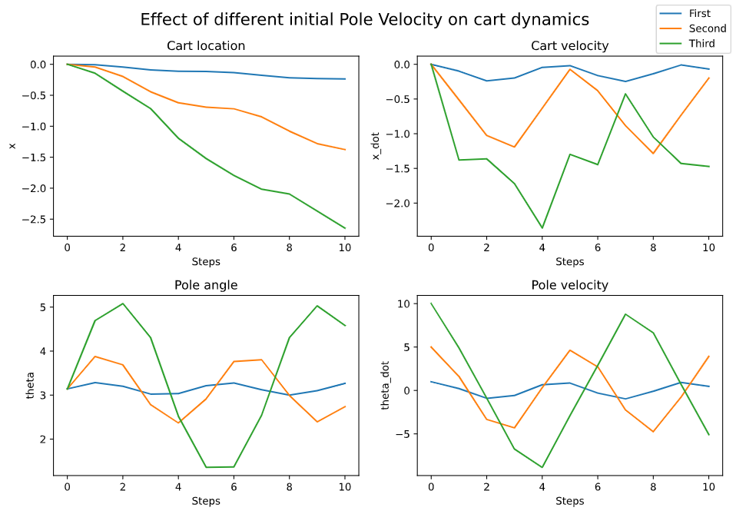

Figure 1. Cart dynamics (discreet) time evolution from a stable equilibrium. The different lines are different initial pole velocities.

Figure 1 shows how the cart behaves when at a stable equilibrium, [0,0,π,0], but the pole velocities are non-zero. The figure has the following initial conditions: First (blue) – [0,0,π,1]; Second (orange) - [0,0,π,5]; Third (green) - [0,0,π,10]. We see, as expected, the higher pole velocities lead to a larger change in cart location (supported by a higher cart velocity), and a large variation in pole angle. The function can also be called to vary a different variable, perhaps cart velocity. Note that the angle is not remapped. We see that in Figure 1, the pole angle never crosses 2π or 0, so I increased the initial conditions to [0,0,π,15]. This produced Figure 2, where we clearly see that multiple full rotations have occurred (from pole angle). Note that unlike Figure 1, the pole velocity is always positive as the pole never “falls back”.

Figure 2. Complete rotations of the pendulum.